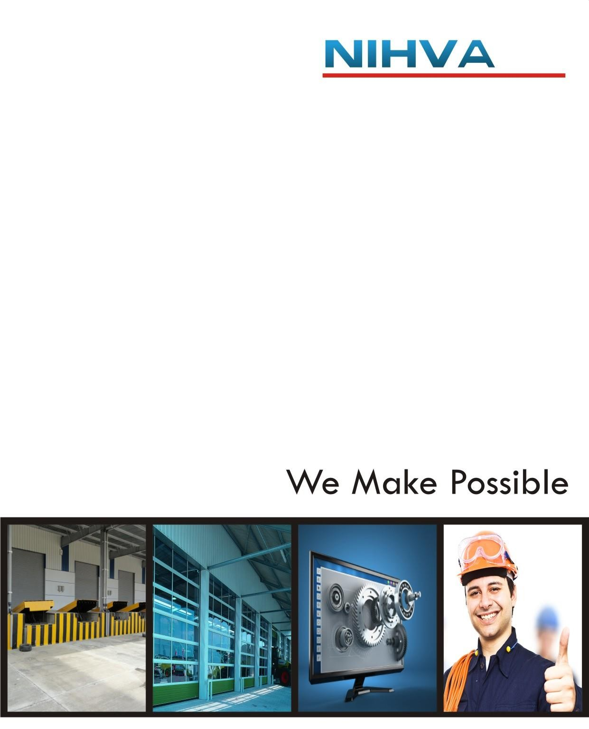

NIHVA Technologies Pvt.ltd
Pune
Company Profile
NIHVA Technologies Pvt. Ltd.

Introduction:
- Name of the Company | NIHVA Technologies Pvt. Ltd.
- Location | 187, G-Block, Thermax Chowk,  MIDC Chinchwad, Pune - 411019
- Contact | +91 8551091333
- Email Id. | sales@nihva.com
- Website | https://www.nihva.com
- Founder and director | Mr. Vijay M Tarak

About Us:-
“NIHVA” specializes in providing integrated solutions in Door automation, customized material handling solutions, factory and warehouse automation, Roof and Window automation, Mobile warehouses Apart from this , for any project our scope commences from under-standing the requirement, functionality, designing & solution to installation and commissioning. Further we prefer to be with you by providing a service backup for a ‘commitment beyond contract’.
We understand the importance of manpower in providing such services to our esteemed customers and therefore we have best Technician, Engineers to ensure trouble free services. Our values and culture drive team empowerment and trusted customer relationships. Our business partners / associates are global market leaders & specialize in application knowledge. The combination of this knowledge & our expertise allows us to appreciate unique business challenge and to support you with the most efficient solution. Our head office is located at Pune in Maharashtra (India). “NIHVA” has always been strongly supported by world leaders in automation. Our commitment is to execute projects with highest quality, on time & within the budget, while adhering to safety, health and environmental standards and to get established as an icon in providing best engineering services.
NIHVA’s commitment to quality and innovation has earned them a reputation as one of the leading automation solutions providers in India. They are a trusted partner for businesses of all sizes who are looking to improve their operations. (In the Boxes)

“NIHVA” has always been strongly supported by world leaders in automation brands.

- Vision
We will be the most valued business partner of our customers
- Mission
We provide intelligent and innovative engineering solutions and services that meet the need of all our customers
- Core Values
Driven by Positive Approach, Attitude & Accountability. Accelerate always Respect, Relations & Results. Continuous Improvement in - Change, Communication, Gratitude, Performance & Leadership Satisfaction and Happiness at the end of every day.
- Core Purpose
Inspire the individuals and organizations by offering Innovative Solutions, Products and Services that enrich people’s lives, save their Efforts, Time, and Money and contribute to social prosperity by creating a new future.

NIHVA Business activities divided in 2 divisions.
- Door Automation
- Automation solution

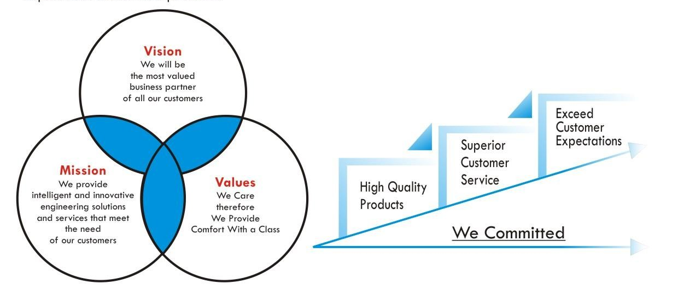

Quality Policy

State-of-the-art, Innovative, High Quality Products
World-class, Superior, Customized and Always-Ready Customer Service and Support
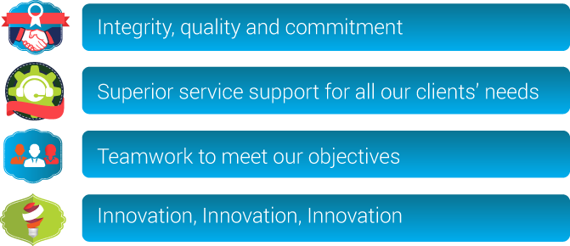
Overachieve and Exceed Customer Expectations
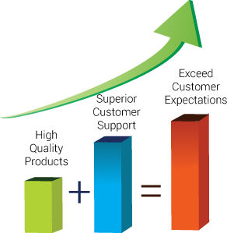

Product line:-

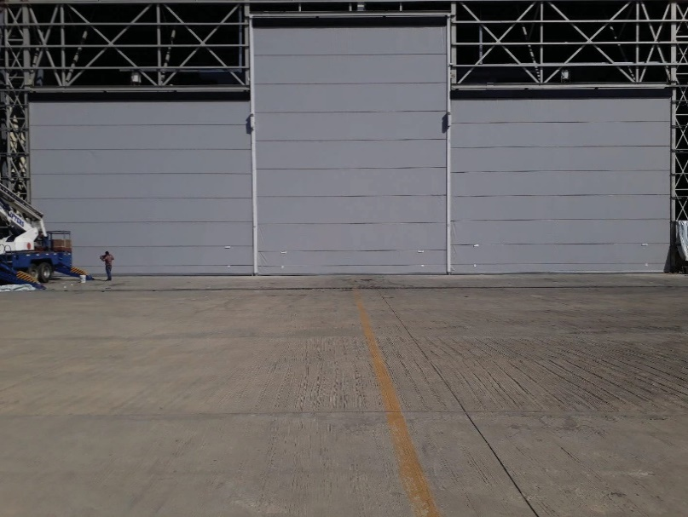
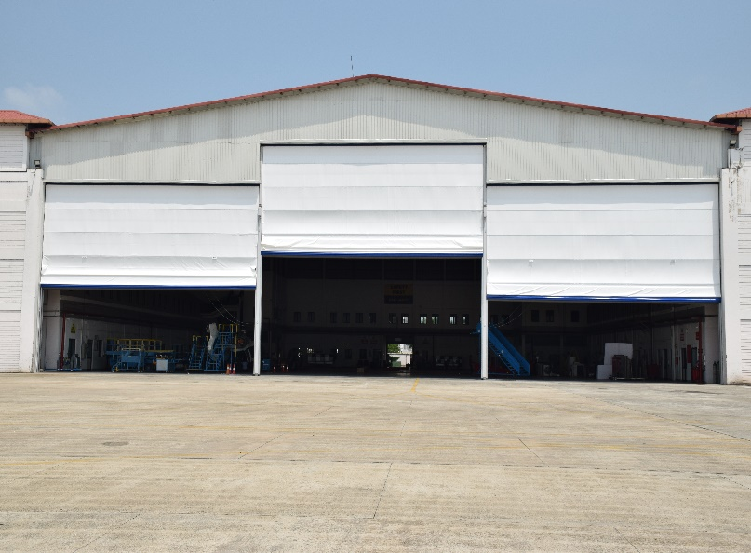
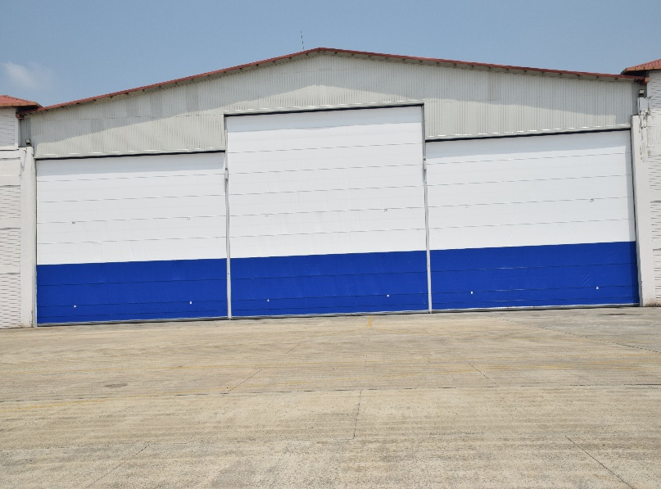
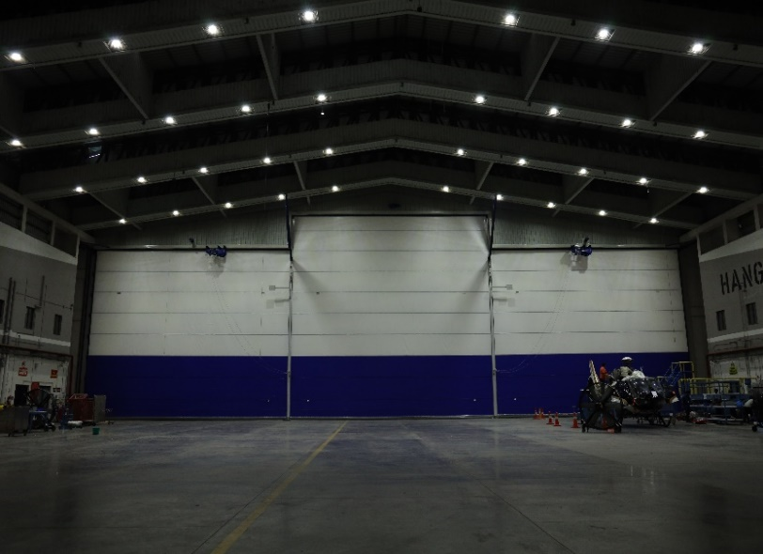
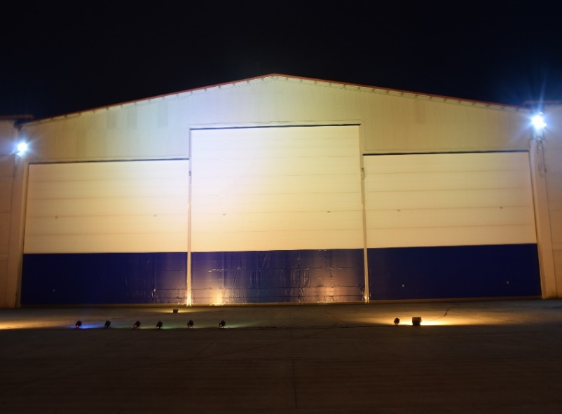
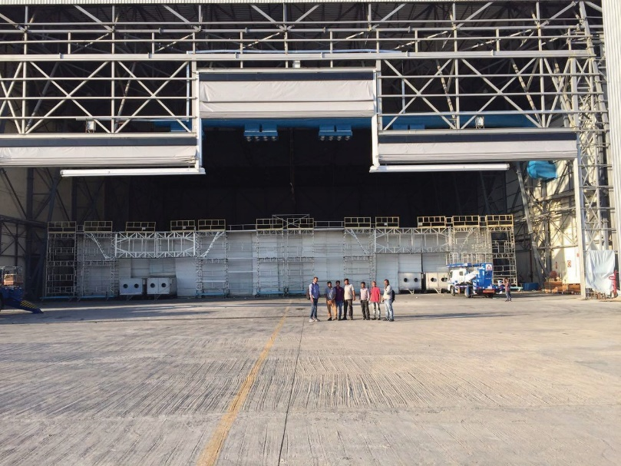
Executed Project
Product catalogue, Technical Data, Detailed specification

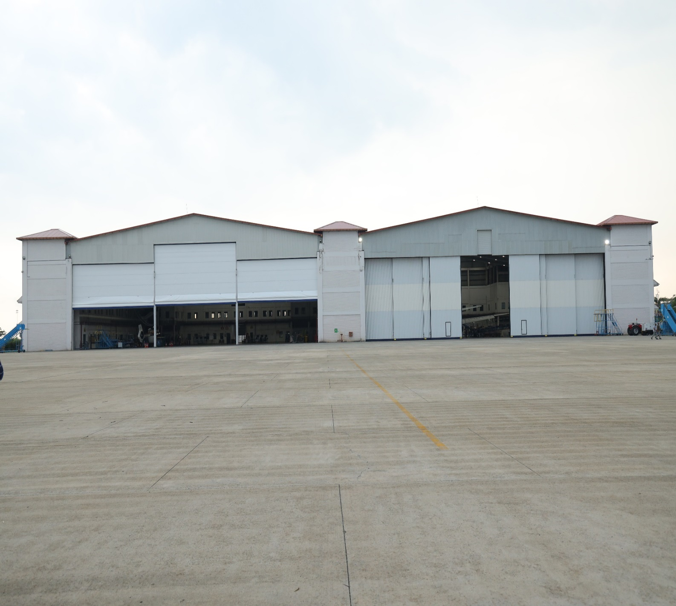
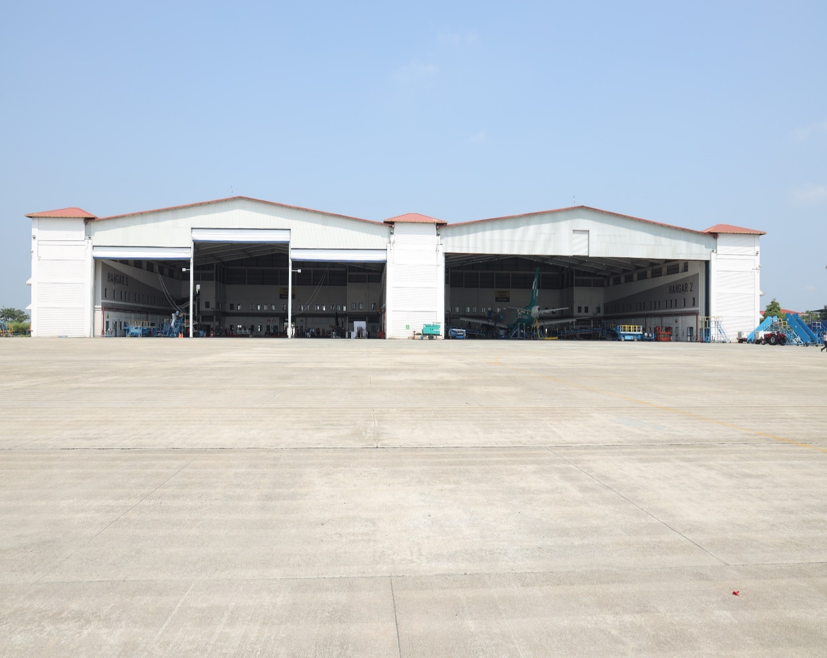
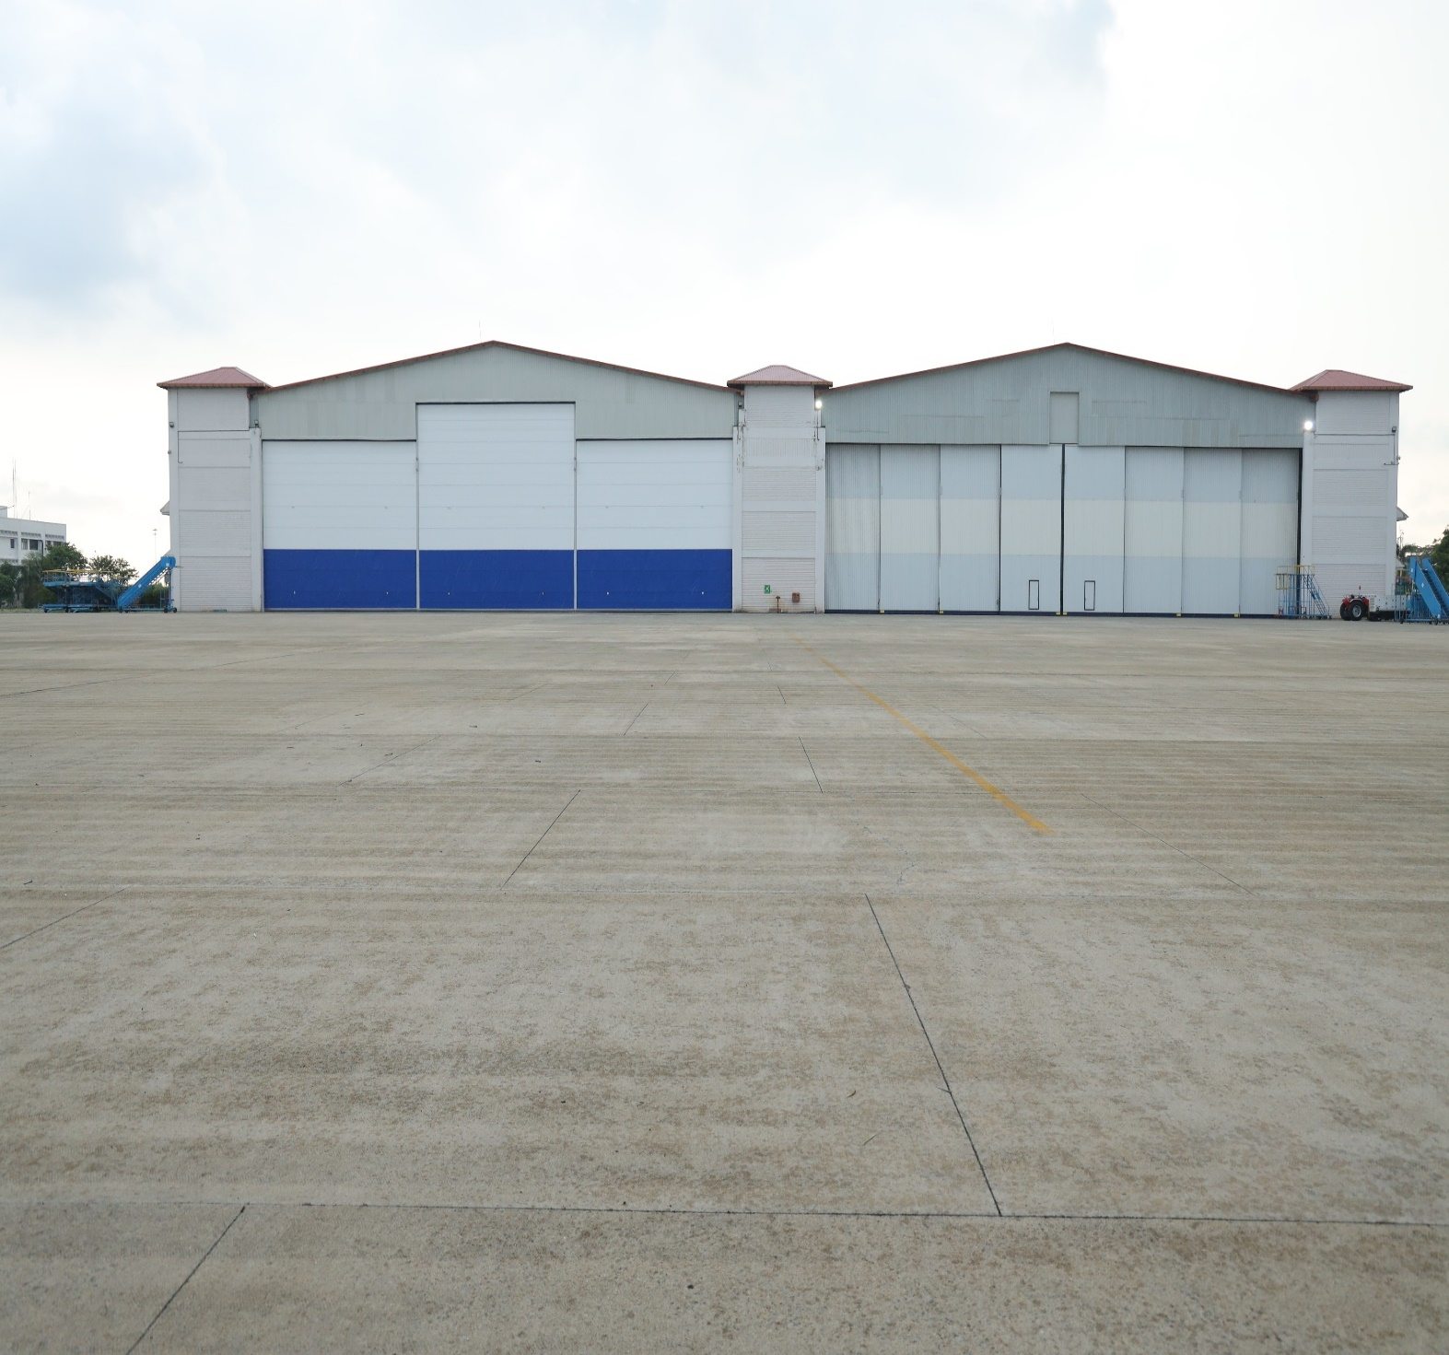
Executed Project

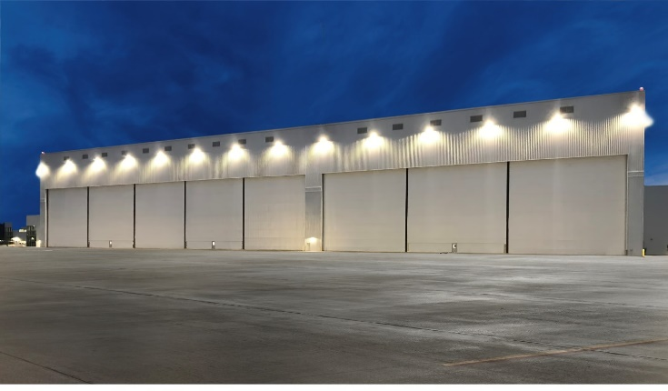
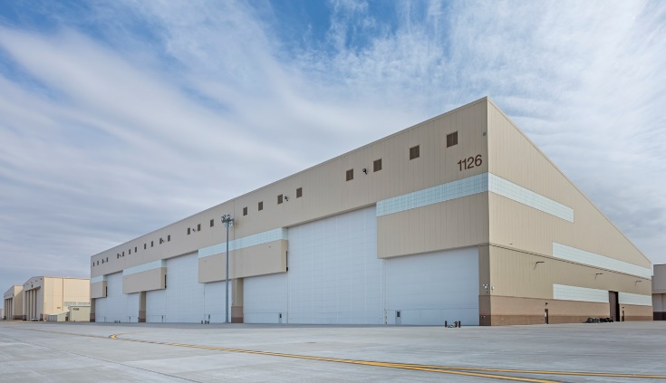
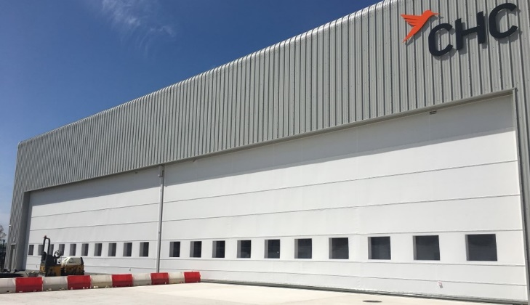

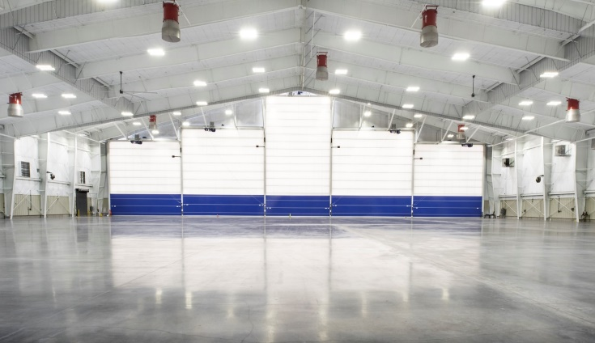
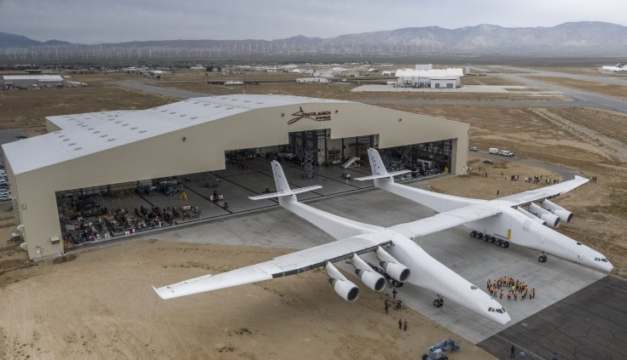

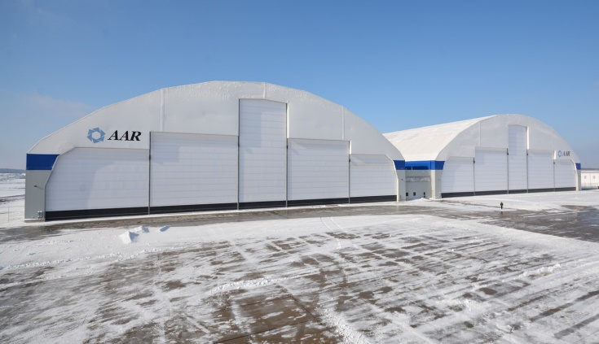
Executed Project

ISO Certificate
Certification
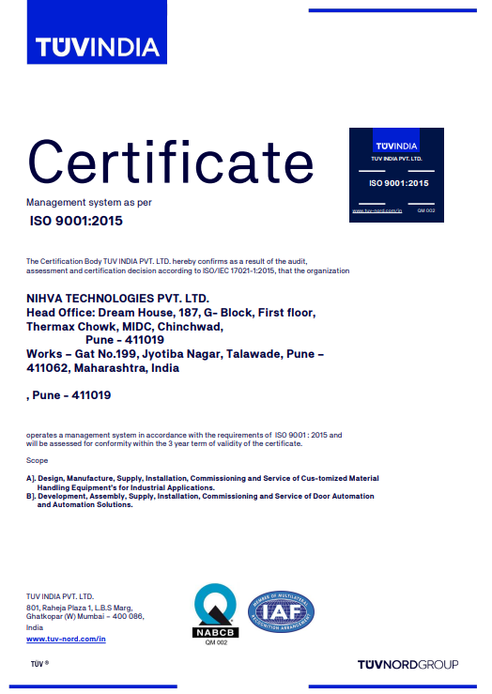
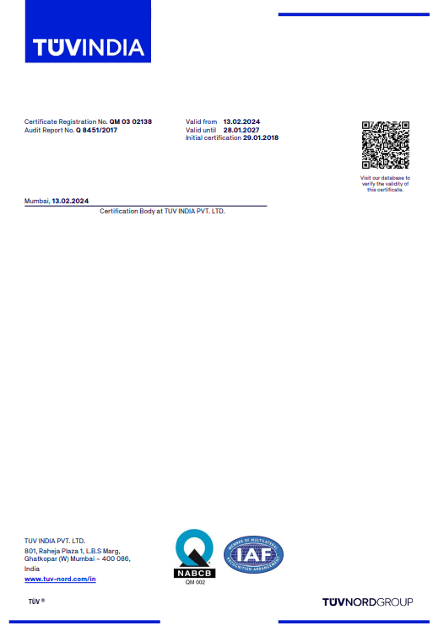
Incorporation Certificate

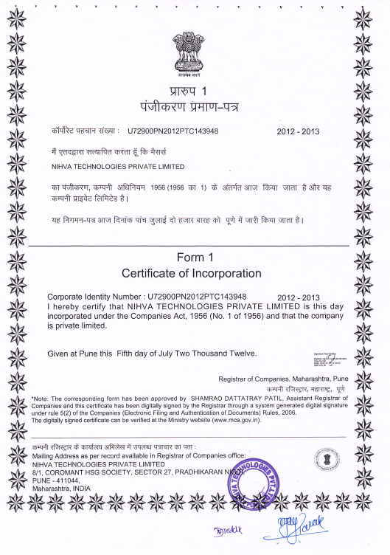
Appreciation Certificates

- AAR-INDAMER

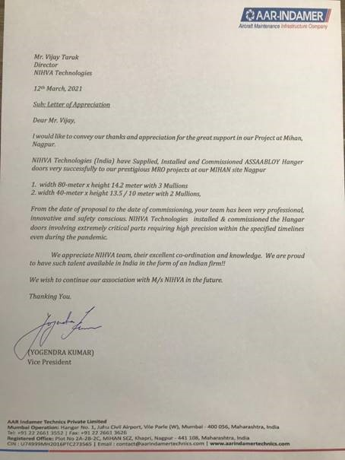
Appreciation Certificates
- GMR-Hyderabad
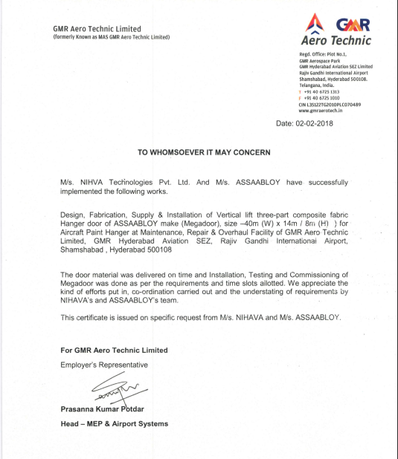
Appreciation Certificates
- ISP

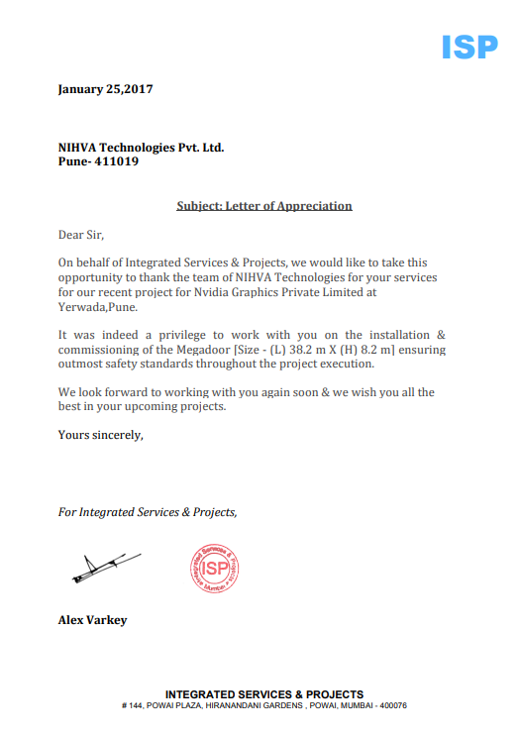

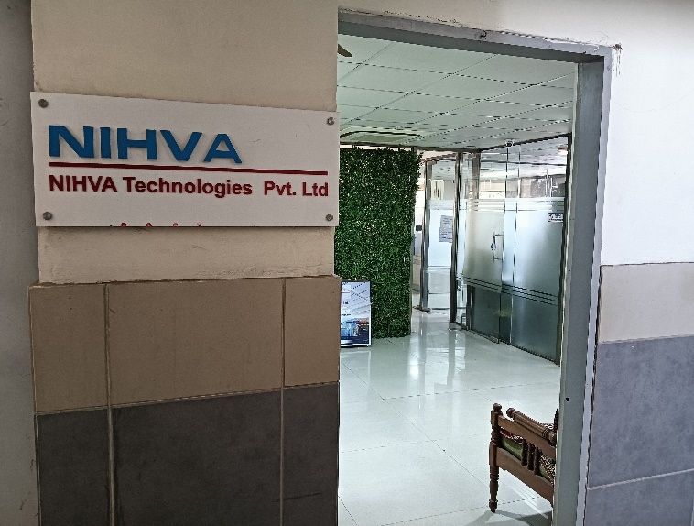
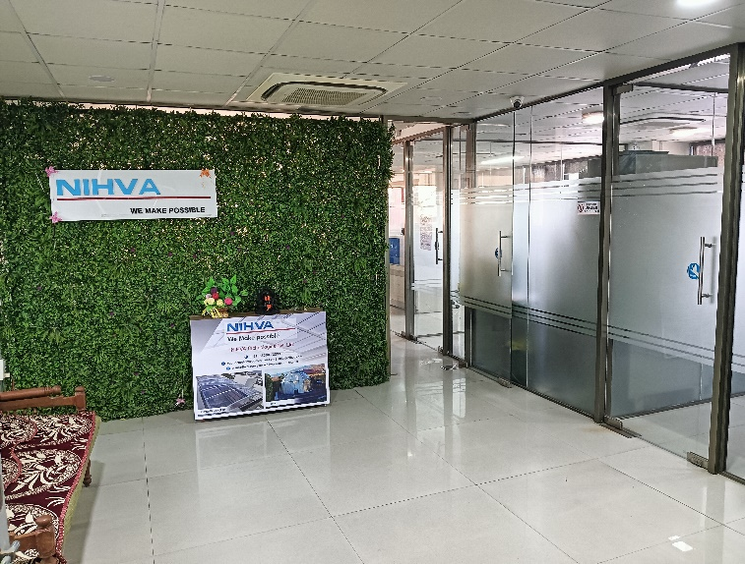
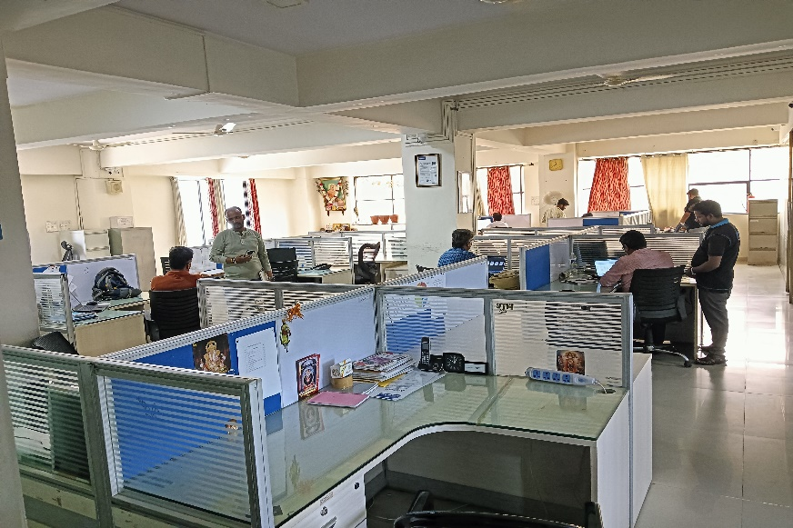
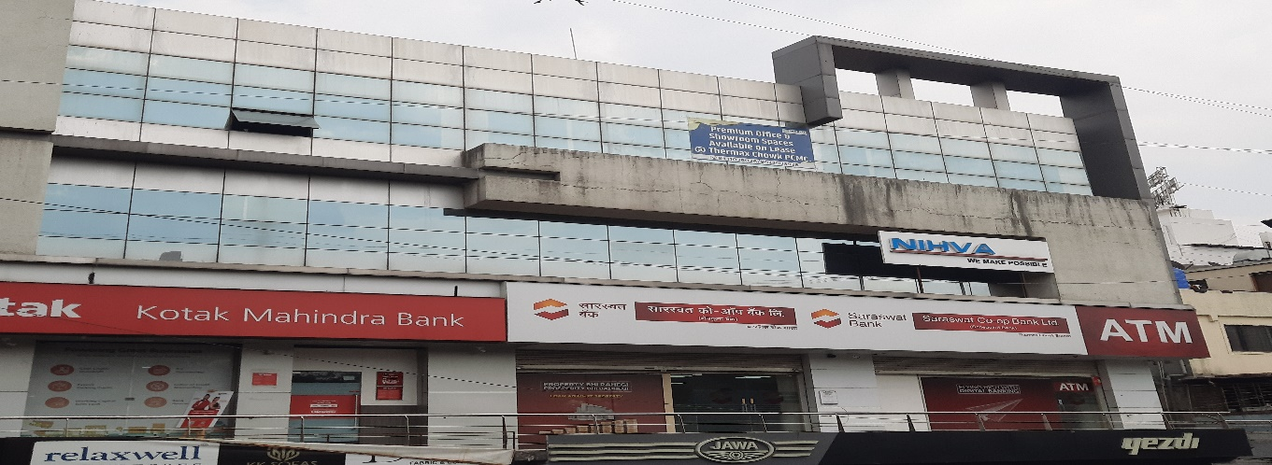
Office
Factory & Office
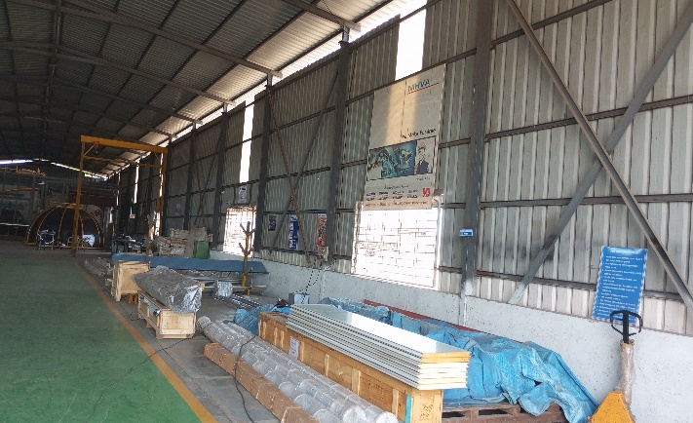
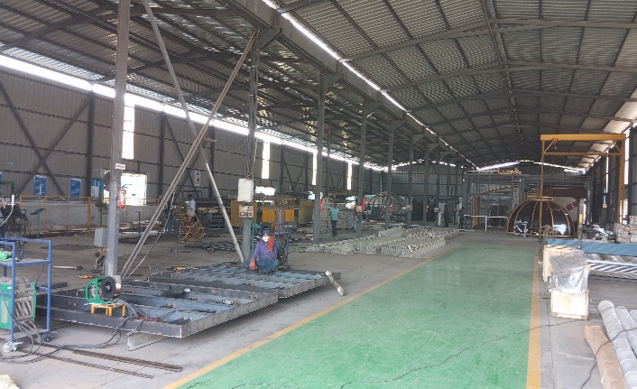
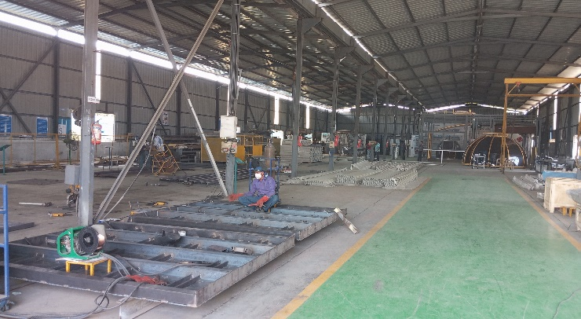
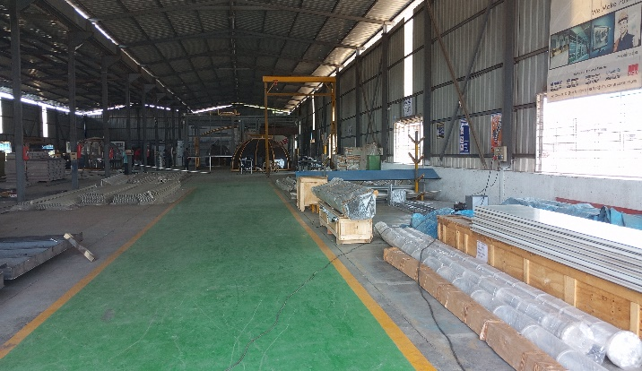
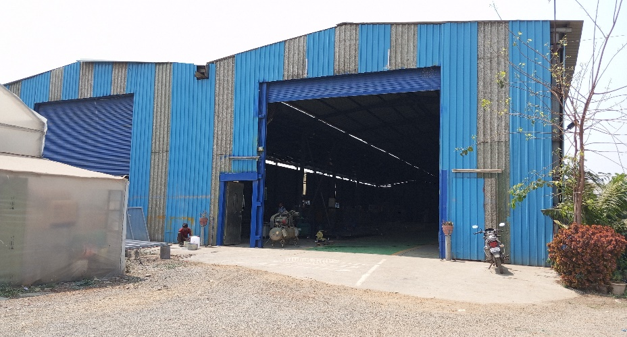
Factory

GST Certificate



